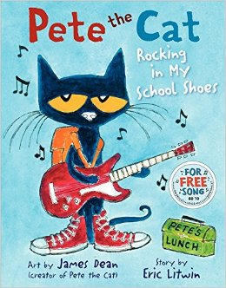

***Pete the Cat***

**By,**

**Eric Litwin**

***My Five Senses***

**By,**

**Aliki**

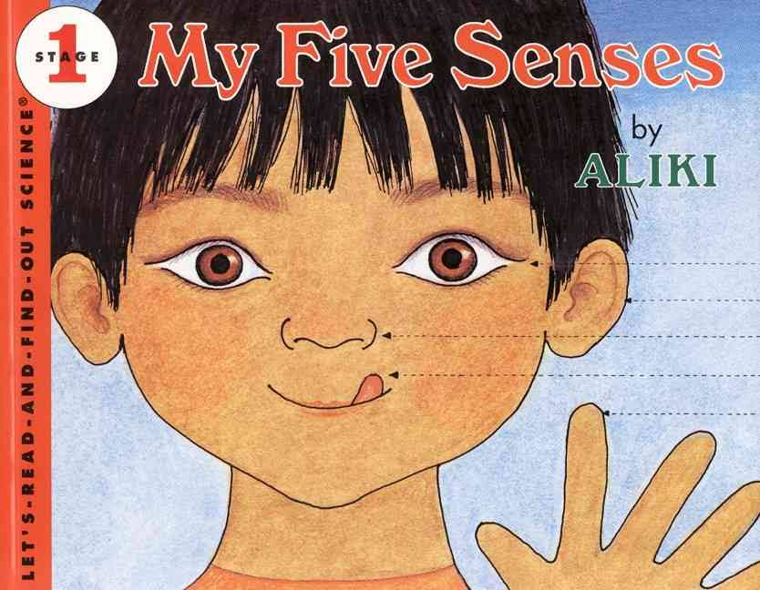

***10 Apples Up on Top***

**By,**

**Dr. Seuss**

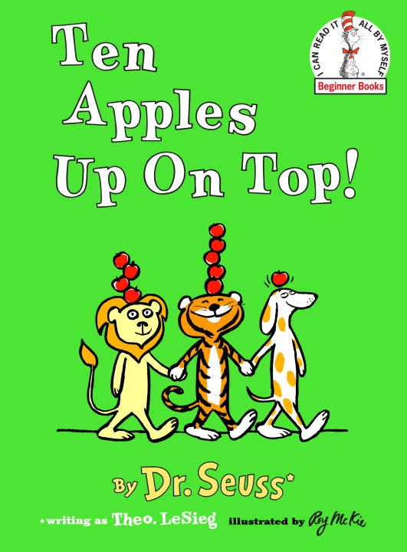

* Our next field Trip is Wednesday, October 4th to Gede’s Farm.
* Picture Retake Day is October 17th.
* **PLEASE, PLEASE, PLEASE** check your child’s New-N-Notes folder daily! This is how we communicate class information. When something gets missed, your child may miss an opportunity for learning and sharing in the classroom. No child wants to be left out!
* The new calendar is on the back of your child’s News-N-Notes folder!
* Ask your child about their friends in the classroom with specific questions such as, “Who did you play with today?” Give choices, such as, "Did you play with puzzles or blocks?" The notes about our centers under “What’s New In the Lizard Room” can give you some ideas about what to ask!!!
* Take a listening walk with your child! What do you hear? Ask your child to describe the sounds he or she hears. Imitating environmental sounds is an important part of language development! Hear the story here:

**https://www.youtube.com/watch?v=BLs4r8lHUSg**

* https://www.**youtube**.com/watch?v=BLs4r8lHUSg

**Your child about school…**

I can’t believe we are into our second month of school! Our classes are in full swing and learning at a rapid pace. We just finished learning about our bodies, our 5 senses, and are working hard on identifying our names and the letters that make them.

As we head into this next month, we will be putting our 5 sense to use to learn about apples, pumpkins, and the changing seasons. We will also begin learning & reviewing the letters starting with “A is for Apples.” A great way to support this is by pointing out the letter A wherever you see it! The more connections you can make with the things your child is learning, the more he or she will remember!

* Many of our ‘Lizards’ still are missing a spare set of clothes, and those who have sent them in may need them replaced with a warmer set. We get messy…we have accidents, and this is part of our learning experience. Please send in a change of clothes for your child in a Ziploc bag with his or her name on the front.
* Children should not begin to arrive for A.M. Preschool until 8:05 a.m., and 11:35 a.m. for P.M. preschool. There WILL NOT be preschool staff there to supervise your children before the stated times.

.

September 30, 2017

Large puzzles with kids bodies to practice naming body parts and self identification.

Apple Market to develop dramatic play, social, and communication skills.

Flannelboard faces to review senses & body. Geo boards for **Geometry & Motor Skills.**

Apple Sorting &

Patterning with

Manipulatives, Apple Maze & Tracing pages for

**Math & Literacy Application**

**\* I can follow rules and routines.**

**\* I can explore with my 5 senses**

**\* I can name familiar body parts**.

**Pair & Share**

**Center**

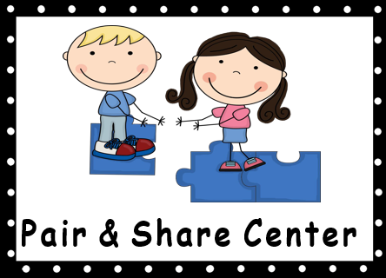

**Pretend**

**Center**

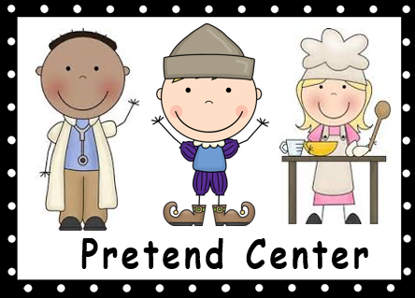

**Table**

**Centers**

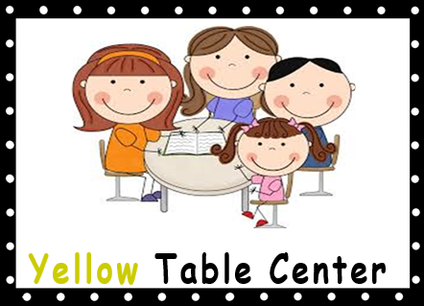

**Carpet**

**Center**

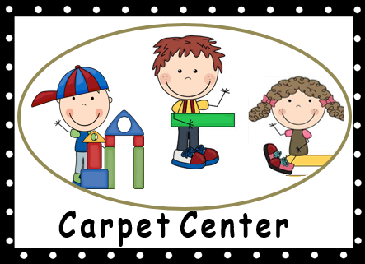

**Books we are**

**Reading:**

ing events in this area.

Lizard News

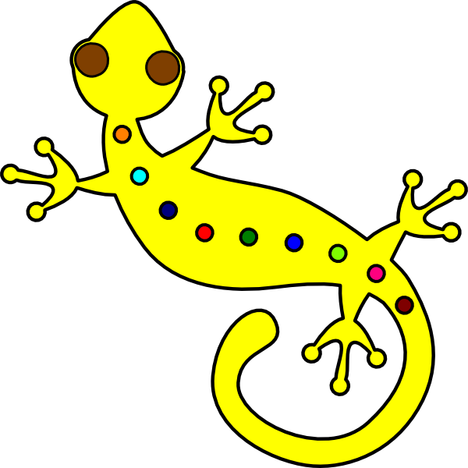

**Mrs. Kramer’s**

**Reminders**

**Things to ask**

**News From Our Class**

**What’s New**

**In the**

**Lizard Room:**

**We are learning:**

**September 16, 2016**

Original design ©2013 by Scott Ralph

**A Few Reminders…**

**Where did September go???**