j0305493

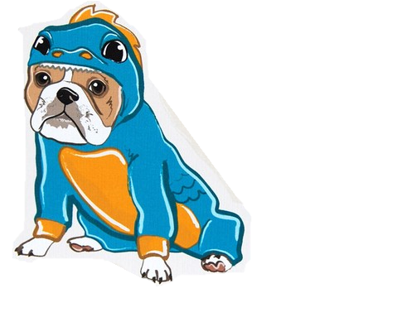

**October**

**2017**

**Lucky Lizards Class**

**Mrs. Kramer**

**skramer@ofcs.net**

**(440) 427-6380**

|  |  |  |  |  |  |
| --- | --- | --- | --- | --- | --- |
| Theme | Monday | Tuesday | Wednesday | Thursday | Fri |
| Apples  Letter A | 2 | 3 | 4  Gede’s Fruit Farm  Field Trip | MC900078821[1]5 | 6 |
| Apples & Pumpkins  Letter P *C:\Users\skramer\AppData\Local\Microsoft\Windows\Temporary Internet Files\Content.IE5\U133QXNN\foodns[1].png* | 9 Bring An Apple  For An  Experiment  Wear Red!!! | 10  Wear Yellow! | 11  Wear Green!! | 12 | Friday13 |
| Pumpkins  Letter O | 16  Pumpkin Science! Image result for cut open pumpkin clip art  Wear Orange! | 17  Picture Retakes | 18 | 19 | 20 |
| Halloween  &  Monsters | 23 | 24 | 25 | 26  Halloween Party!MC900410573[1] | 2MCj04127120000[1]7 |
| Tentative:  Fall | 30 | 31 | 1 | 2  Leaf Raking Day!  Image result for leaf raking clip art | 3 |

