j0305493

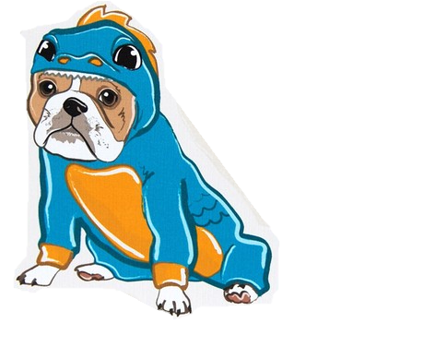

**October**

**2016**

**Lucky Lizards Class**

**Mrs. Kramer**

**skramer@ofcs.net**

**(440) 427-6384**

|  |  |  |  |  |  |
| --- | --- | --- | --- | --- | --- |
| Theme | Monday | Tuesday | Wednesday | Thursday | Fri |
| Apples  Letter A | 3 | 4 | 5 Letter A  Show and Tell Day! | 6  Gede’s Fruit Farm  Field Trip MC900078821[1] | 7 |
| Apples & Pumpkins  Letter P *C:\Users\skramer\AppData\Local\Microsoft\Windows\Temporary Internet Files\Content.IE5\U133QXNN\foodns[1].png* | 10  Wear Red!!! | 11  Bring An Apple  For An  Experiment!!  Wear Yellow! | 12    Wear Green!! | 13  Letter P  Show and Tell! | Friday14 |
| Pumpkins  Letter O | 17  Wear Orange! | 18  Picture Retakes | 19 | 20  Letter O  Show and Tell! | 21 |
| Halloween  &  Monsters | 24 | 25 | 26 | 27  Halloween Party!MC900410573[1] | 28 MCj04127120000[1] |
| Tentative:  Fall | 31 | 1 | 2 | 3 | 4 |

