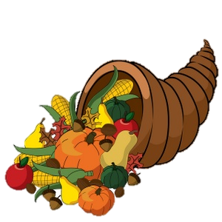

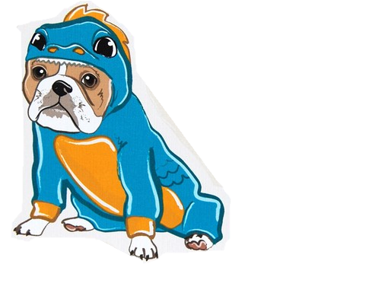

**Novemberr**

**2016**

**Lucky Lizards Class**

**Mrs. Kramer**

**skramer@ofcs.net**

**(440) 427-6384**

|  |  |  |  |  |  |
| --- | --- | --- | --- | --- | --- |
| Theme | Monday | Tuesday | Wednesday | Thursday | Fri |
| Monsters  Letter M | **ELA Assessment Observations & Data Recording** | 1 | 2 | MC900078821[1]3 | 4 |
| Leaves &  Fall Changes, Letter L  *C:\Users\skramer\AppData\Local\Microsoft\Windows\Temporary Internet Files\Content.IE5\83X3CDDX\lgi01a201409050100[1].jpg* | 7    Parent Teacher  MC900334112[1]Conferences    **ELA Assessment Observations & Data Recording** | 8 | 9 | 10  Letter L  Show and Tell! | 11 |
| Food  Letter F  C:\Users\skramer\AppData\Local\Microsoft\Windows\Temporary Internet Files\Content.IE5\KMLAHR16\food[1].jpg | 14 | 15 | 16  Shaker’s IGA  Field Trip  MC900044899[1] | 17 Letter F  Show and Tell!    MC900334112[1]Parent Teacher  Conferences | 18 |
| Thanksgiving & Food Cont’d C:\Users\skramer\AppData\Local\Microsoft\Windows\Temporary Internet Files\Content.IE5\U133QXNN\thanksgiving-charlie-brown-snoopy[1].jpg | 21 | 22 Finger Food  Thanksgiving  Feast  {Happy Thanksgiving Day 2014} Turkey Clip Arts/Craft Picture/Cartoon Images Download | ThanksGiving Day 2014 Festival Sms Wishes Wallpapers: | MCj04359670000[1]23 MCj04359670000[1]  No  School | MCj04359670000[1]MC900410573[1]24C:\Users\skramer\AppData\Local\Microsoft\Windows\Temporary Internet Files\Content.IE5\KMLAHR16\PeanutsThanksgiving[1].jpg | MCj04127120000[1]25  No  School |
| Fairy Tales  & TraditionsC:\Users\skramer\AppData\Local\Microsoft\Windows\Temporary Internet Files\Content.IE5\83X3CDDX\fairy-tale-book-theme-image-1-26344546[1].jpg | 28 | 29 Wear your  Pajamas to school!  Image result for pajamas clip art | 30 | 1 | 2 |

