Dear Families;

We are very excited that the ECC has purchased a program designed to enhance student auditory comprehension! The program is called HearBuilder, and it targets very specific skills that many of our students need!

HearBuilder is a systematic learning program for PreK to eighth-grade students that provides individualized instruction in basic concepts, following directions, phonological awareness, sequencing, and auditory memory.

With HearBuilder, our goal is to:
- Target skills for success in school
- Rely on evidence- and research-based learning
- Support state and Common Core State Standards
- Have multi-level activities with specific objectives
- Strengthen the school and home on learning with the technology of computers and tablets

The HearBuilder Collection consists of four award-winning software titles:
- Following Directions
- Auditory Memory
- Sequencing
- Phonological Awareness

HearBuilder gives students access to research-based, interactive programs that can be used online. Our district subscription allows us to offer the same skill building games to you customized to your child’s needs through apps! Students can use the software on a tablet, laptop or desktop in the classroom AND at home. Each program offers multi-level activities with progress monitoring for educators and administrators to track student progress.

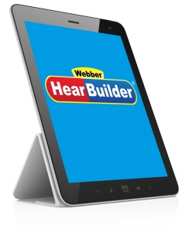
An account has been set up for your child, and you can begin playing through your home computer, phone, or tablet. (It’s free!)

To play on your computer, just go to https://my.hearbuilder.com/student/login.aspx and
enter the login information from the next page.

If you would like your child to play HearBuilder Online on an iPad®, first download any of the four free apps from the iTunes® store. If using an Android™ tablet, download each free app from Google® Play or the Amazon® Appstore. Your child will need to open the app for the program he/she needs to play and enter the user name, password, and login code. The apps require a WiFi internet connection.

The instructions for you to begin using the program at home are attached. PLEASE join us in the trial, so we can see if this program is as beneficial as we hope it will be in supporting student learning, as well as home to school learning. We welcome your feedback! We are partners in your child’s education, and we thank you in advance for your collaboration.

Most sincerely,
Suzanne R. Kramer
Suzanne R. Kramer, ECIS

®
Instructions for Home Use
HearBuilder Online is a software program that provides systematic instruction in basic concepts, following directions, phonological awareness, sequencing, and auditory memory. Students receive their own login and can use the program at school and at home.

We would like your child to continue using HearBuilder Online at home 3 days a week for 10 minutes per day. Here’s how!

Log In

Go to my.hearbuilder.com/student
  - Enter your child’s first name and last initial, password, and school code. (Example: Jane Doe would be JaneD)
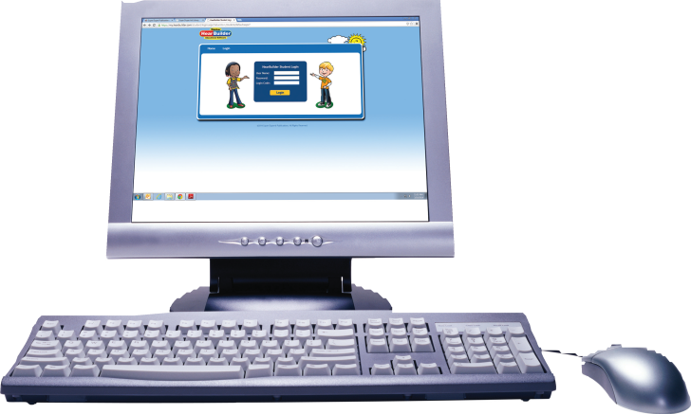
User Name: Password: bulldog School Code: A64P
(Please note all areas are case sensitive.)

  - Click Login.

Play
  - Click Play under any of the 4 games.
  - The program will automatically start where your child ended his/her last session.

There’s also an app! (It’s free!)
If you would like your child to play HearBuilder Online on an iPad®, first download any of the four free apps from the iTunes® store. If using an Android™ tablet, download each free app from Google® Play or the Amazon® Appstore. Your child will need to open the app for the program
he/she needs to play and enter the user name, password, and login code. The apps require a WiFi internet connection.

Troubleshooting
- HearBuilder Online is a portal login. That means it is not accessible through a search engine such as Google®, Bing®, or Yahoo®. Therefore, please use the link listed above in step 1. You can save the page as a Bookmark or Favorite on your computer to easily access it every time.
- Make sure your computer is connected to the internet. HearBuilder Online is compatible with any Windows® or Macintosh® operating system as long as the computer is connected to the internet.
- HearBuilder Online is compatible with the following internet browsers on a computer: Internet Explorer®, Safari®, Firefox®, and Google Chrome™.
- If you experience a blank page after clicking Play, make sure you have the latest version of Adobe® Flash® Player installed. You can download the latest version here: http://get.adobe.com/flashplayer/
- If you get a pop-up screen that says “Internet Explorer restricted this webpage from running scripts or ActiveX controls,” click the button that says Allow Blocked Content.

If you’re still having trouble, call HearBuilder Online Support at 1-855-735-0862, available Monday through Friday, 8:30 a.m. to 5:00 p.m. EST.

