



* Many of our ‘Lizards’ still are missing a spare set of clothes, and those who have sent them in may need them replaced with a warmer set. We get messy…we have accidents, and this is part of our learning experience. Please send in a change of clothes for your child in a Ziploc bag with his or her name on the front.
* We will have Holiday Break from December 21st through January 2nd. School resumes on January 3rd.

.

**A Few Reminders…**

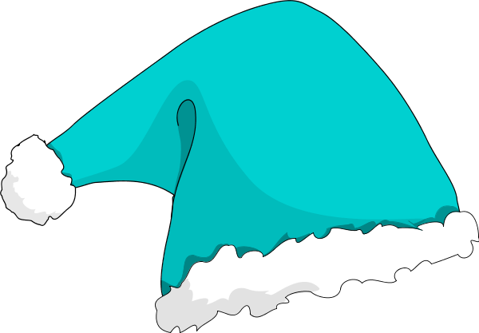





I can’t believe it is December! We are busy all the time, and the learning happens fast. This is the time of year where we have many projects going on, and we can always use help! If you have a craft or activity that you would like to do with the children, email or call me to let me know! If that is not your thing, but you would like to help out…we ALWAYS appreciate help and ‘crowd control!’ We take volunteers ANYTIME, not just for parties!

Throughout the month, we will be talking about Fairy Tales and Family Traditions. We talk about Fairy Tales being ‘old stories that families used to tell teach us a lesson.’ This leads the children to tell stories about their own families and traditions, and we have some diverse cultures in our room. Fairy Tales have an important place not only in literacy, but in Social Emotional Development as well. A great article to read on why Fairy Tales should be part of your home library can be found at : **http://imaginationsoup.net/2012/02/22/fairy-tales-are-essential-to-childhood/**

* Ask your child about their friends in the classroom with specific questions such as, “Who did you play with today?” Give choices, such as, "Did you play with puzzles or blocks?" The notes about our centers under “Some things that are New” can give you some ideas about what to ask!!!
* This time of year lends itself to early reading and writing skills naturally. Let your child go through catalogs and ads while you point out the letters. Have your child ‘write’ the things they want by copying or even scribbling. If your child asks, write for them while spelling

the words aloud as you write.

***Somebody***

***and the***

***Three Blairs***

**By,**

**Marilyn Tolhurst**

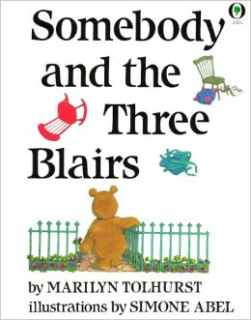

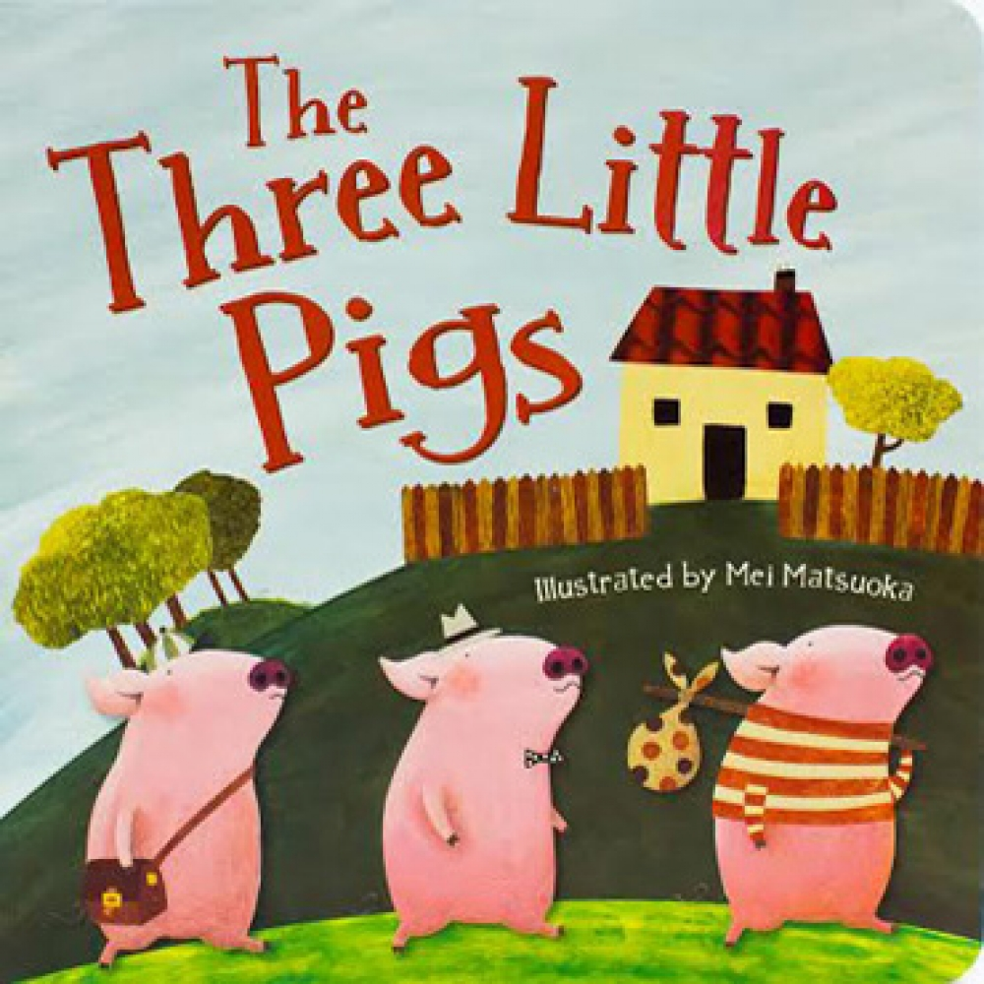

**Some Things**

**that are new**

**in the**

**Lizard Room:**

Retro

Light Bright toys with pegs for

**Fine Motor Development.**

**Touching**

**Table**

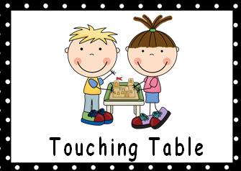

Play houses

with props and Pig/Wolf costumes for

**Language Arts**

**&**

**Literacy Development**

“Brick” Blocks

for

**Motor** **Development**

**&**

**Planning**

as well as

**Social Skills**

**\* I can follow rules and routines.**

**\* I can explore with my 5 senses**

**\* I can name familiar body parts**.

***The***

***Three Bears***

**By,**

**Byron Barton**

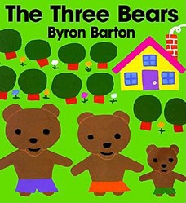

***The***

***Three Little Pigs***

**(Classic)**

* Our next field Trip is Thursday, December 8th to the High School for some Holiday Fun. Due to the large number of High School Students interacting with the children that day, we do not take parents with us on this trip.
* **PLEASE, PLEASE, PLEASE** check your child’s New-N-Notes folder daily! This is how we communicate class information. When something gets missed, your child may miss an opportunity for learning and sharing in the classroom. No child wants to be left out!
* The new calendar is on the back of your child’s News-N-Notes folder!

**Your child with learning…**

December 1, 2016

Bear Size Sorting &

Patterning, and

Fairy Tale File Folder Games for

**Math &**

**Literacy Application**

**Pretend**

**Center**

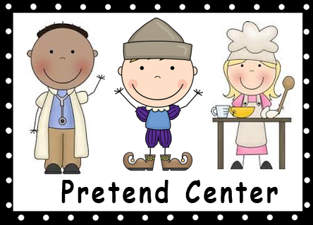

**Table**

**Centers**

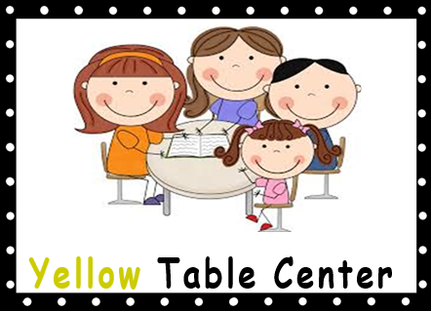

**Carpet**

**Center**

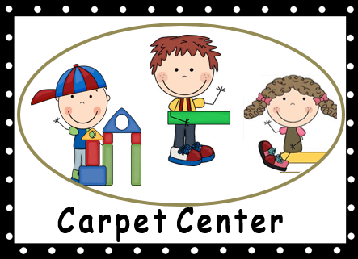

**Books we are**

**Reading:**

ing events in this area.

Lizard News

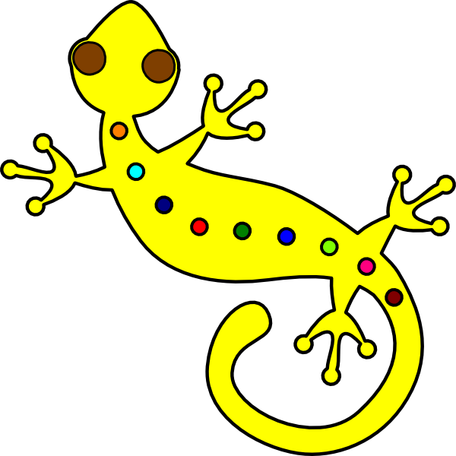

**Mrs. Kramer’s**

**Reminders**

**Things to help**

**News From Our Class**

**We are learning:**

**September 16, 2016**

Original design ©2013 by Scott Ralph

**It’s the most wonderful time…**