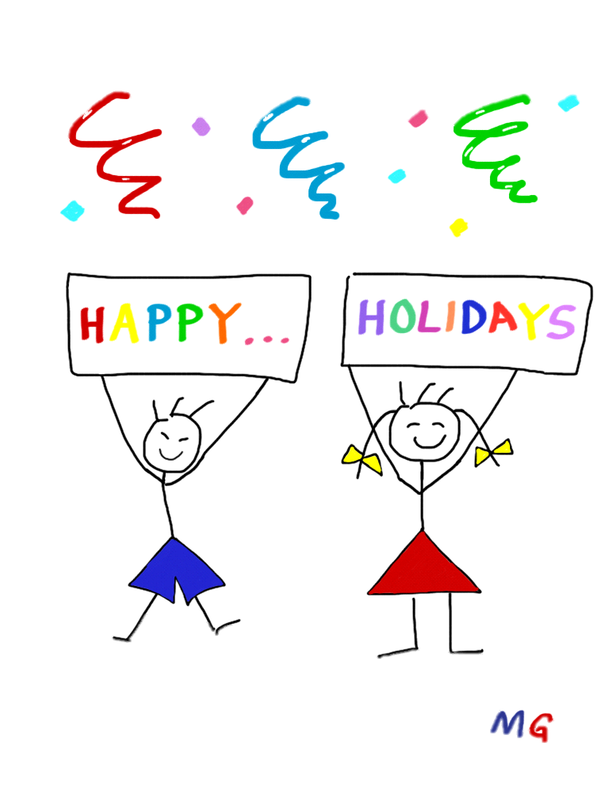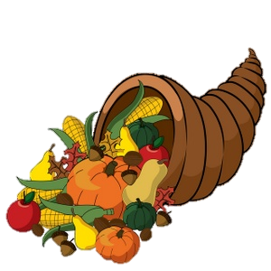



**December**

**2016**

**Lucky Lizards Class**

**Mrs. Kramer**

**skramer@ofcs.net**

**(440) 427-6384**



|  |  |  |  |  |  |
| --- | --- | --- | --- | --- | --- |
| Theme | Monday | Tuesday | Wednesday | Thursday | Fri |
| Fairy Tales  &  Traditions,  Letters F & T |  |  |  | 1 | 2 |
| Fairy Tales  &  Traditions,  Letter T | 5 | 6 | 7 Letter ‘T’  MCj04127120000[1] Show and Tell Day!MCj04127120000[1] | 8 Field Trip  to  MC900433887[1]High School | 9 |
| The 3 Bears,  Letter B  C:\Users\skramer\AppData\Local\Microsoft\Windows\Temporary Internet Files\Content.IE5\83X3CDDX\goldilocks_and_the_three_bears_by_psychoafro[1].jpg | 12 | 13  Secret Project | 14  Secret ProjectMCj04127120000[1] | 15 Letter ‘B’  MCj04127120000[1]Show and Tell Day! | 16 |
| C:\Users\skramer\AppData\Local\Microsoft\Windows\Temporary Internet Files\Content.IE5\83X3CDDX\HappyHolidays[1].gif | 19 | 20  MPj04403320000[1]Holiday Party | 21  No School | 22  No School | 23  No School |
| C:\Users\skramer\AppData\Local\Microsoft\Windows\Temporary Internet Files\Content.IE5\KMLAHR16\6450750121_a71ecb71a1_z[1].jpg | 26  No School | 27  No School | 28  No School | 29  No School | 30 School  Resumes  January 3rd!C:\Users\skramer\AppData\Local\Microsoft\Windows\Temporary Internet Files\Content.IE5\HUWGAK3O\happy_new_year_clipart_2015_(3)[1].png |

